STAFF MODIFIERS

ASAM 1.0-AR, 1.0 and 2.1
- Ensure the User Creation Forms are updated for all qualified staff.
- Select the appropriate performing provider license type when entering treatment services or enter the correct modifier/NPI number on the 837 claim.
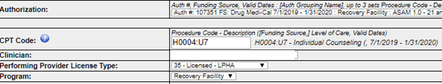

ASAM 3.1, 3.3, and 3.5
- Submit the Staff Modifier Attestation Form for each site address and corresponding level(s) of care to SAPCMonitoring@ph.lacounty.gov with copy to your assigned Contract Program Auditor.
- Enter claims for all services delivered each day that identify the credentials of the individual delivering the service. Submission of per service claims require use of $0.00 codes (i.e., Treatment Plan - T1007, Group Counseling - H0005) in addition to the Clinical Day Rate (e.g., H0019) and Room and Board (e.g., S9976).
- Ensure that the total hours entered match the minimum weekly requirement for the LOC, except when otherwise documented in the patient’s file due to other factors such as medical needs.
- Submit claims using the agency determined Staff Modifier while awaiting SAPC approval and select the appropriate modifier during the claims submission process (see screenshots above). If based on the SAPC review, the agency selected an incorrect Staffing Modifier category, claims will need to be corrected.
- Reduce the Staff Modifier on a temporary basis, and without SAPC approval, if a vacancy or leave in excess of 30-days results in non-compliance with the minimum criteria for the staff modifier rate.
- Submit a revised Staff Modifier Attestation Form if a significant staffing structure change occurs that permanently moves the site to a higher or lower staff modifier category (e.g., positions added or removed).

ASAM 1-WM, 2-WM, 3.2-WM, 3.7-WM, 4-WM
Staff Modifiers are not applicable at this time. SAPC is in the process of reviewing programmatic and staffing requirements for these levels of care, and will reconsider this at that time.

POPULATION MODIFIERS
Youth Ages 12 through 17
- Ensure that the youth serving site is added to the Drug Medi-Cal Contract, online provider directory known as the Service and Bed Availability Tool (SBAT) and complies with all youth specific requirements. The enhanced rate only applies when the individual served is a youth aged 12 through 17, and services are delivered at an approved location.
- Submit Member Authorizations using the authorization grouping with “12-17” in the name for the level of care requested grouping.
- Submit Claims under the “HA” modifier”.

Young Adults Ages 18 through 20
The population modifier for individuals ages 18 through 20 has been delayed pending a solution on how to ensure that this age group receives specialized services. At this time, Sage is unable to distinguish between providers that qualify as a specialty program as outlined under the Youth Ages 12 through 17 section, and those that function as an adult specific program for those 18 years of age and above. SAPC will not reimburse for services delivered between July 1, 2019 and the date of configuration using the population modifier for individuals ages 18 through 20 years of age.

Pregnant and Parenting Women
- Ensure that the pregnant and parenting women site is added to the Drug Medi-Cal (DMC) Contract, online provider directory known as the SBAT, and complies with all youth specific requirements. The enhanced rate only applies when the individual served is a pregnant or parenting woman, and services are delivered at an approved location.
- Submit Member Authorizations using the “PPW- Perinatal or PPW Parenting” grouping for the requested level of care.
- Submit Claims under the “HD” modifier

DOCUMENTATION TIME

Sage is being configured to better operationalize the new documentation requirements and enable submission of associated claims. For primary Sage users start and end times for documentation will be added to the Progress Note and Miscellaneous Note. In the meantime (or if the organization uses a different electronic health record), the start and end time, and the date completed, must be included in the Progress Note or Miscellaneous Note (or equivalent) if the time is claimed for reimbursement. In addition, the following will apply during the configuration process:

ASAM 1.0-AR, 1.0 and 2.1
- Group Counseling and Patient Education:
  - Add the start and end time, and the date documentation was completed to the Progress Note or Miscellaneous Note.
  - Indicate within the Progress Note or Miscellaneous Note if the service occurred at an approved field-based services location, or via telephone or telehealth.
  - Submit claims using the 15-minute increment model based on number of group participants (e.g., 2-4 participants one 15-minute unit).
  - If the actual time to document the service was less than the total time claimed, the difference may be subject to recoupment.
- Individual-Based Services:
  - Add the start and end time, and the date documentation was completed to the Progress Note or Miscellaneous Note.
  - Indicate within the Progress Note or Miscellaneous Note if the service occurred at an approved field-based services location, or via telephone or telehealth.
  - Add up to one-unit to the duration of the session to account for actual documentation time as indicated in the Progress Note or Miscellaneous Note.
SAMPLE: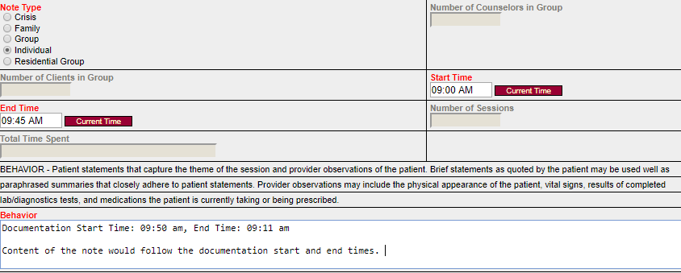
Start Time 9:50 am to End Time 10:00 am

ASAM 3.1, 3.3, 3.5 1-WM, 2-WM, 3.2-WM, 3.7-WM, and 4-WM
- Submit an agency-wide Policy and Procedure (each residential and withdrawal management location under the DMC contract must participate) indicating use of either a per service or per day standard for documentation to SAPCMonitoring@ph.lacounty.gov with copy to your assigned Contract Program Auditor.
- Add the start and end time, and the date documentation was completed to the per service or per day Progress Note or Miscellaneous Note.
- Enter claims for all services delivered each day.
- Ensure that the total hours entered match the minimum weekly requirement for the LOC, except when otherwise documented in the patient’s file due to other factors such as medical needs.

Shortly, Primary Sage Users will be able to enter the start and end time and corresponding date of documentation time into the Progress Note or Miscellaneous Note.

TRAVEL TIME

The travel time allowance for field-based services has been delayed pending a solution on how to configure this within the Sage. SAPC will not reimburse for travel time for services delivered between July 1, 2019 and the date of configuration.

SCREENING

The processes to claim for the Youth Engagement Screener or Co-Triage screening, when paired with completion of the new Referral Connections Form, is underway. SAPC will not reimburse for screenings completed between July 1, 2019 and the date of configuration.

OPIOID TREATMENT PROGRAMS AND BUPRENORPHINE

Submit the name and qualifications of the Drug Enforcement Administration (DEA) X-Waivered physician at each Opioid Treatment Program (OTP) site responsible for prescribing buprenorphine to SAPCMonitoring@ph.lacounty.gov with copy to your assigned Contract Program Auditor.

STAFF MODIFIER ATTESTATION FORM
INSERT AGENCY attests that as of INSERT DATE, the staffing pattern at INSERT SITE/ADDRESS which provides ASAM INSERT LOC # services, qualifies for the following staff modifier: ☐ 0%-Base Rate, ☐ 6%-SUD Counselor, ☐15%-Licensed Eligible LPHA, or ☐20% Licensed LPHA according to the criteria outlined in the Fiscal Year 2019-2020 Rates Information Notice (IN). INSERT AGENCY confirms that it will maintain the following staffing pattern and the provision of direct services as required throughout Fiscal Year 2019-2020 unless a new form is submitted, and agrees to suspend submission of claims using the approved staff modifier category when a prolonged change in excess of 30-days (e.g., vacancy, extended leave) results in a staffing pattern that no longer qualifies for the enhanced rate (this excludes use of sick, holiday, and vacation time in accordance with the agency’s benefits package and established policy). INSERT AGENCY understands that it can submit claims under the next appropriate staffing modifier category (e.g., 15% 6%) without SAPC approval if applicable.
ASAM 3.1 , 3.3, and 3.5 Bed Capacity Staffing Pattern
Total # of DHCS Licensed Beds at the Site for Residential Services |  | INSERT # BEDS
Total # of Beds at the Site for LAC DMC-ODS Residential Services |  | INSERT # BEDS
Of Total LAC DMC-ODS, Target Number of Beds for ASAM 3.1 |  | INSERT # BEDS
Of Total LAC DMC-ODS, Target Number of Beds for ASAM 3.3 |  | INSERT # BEDS
Of Total LAC DMC-ODS, Target Number of Beds for ASAM 3.5 |  | INSERT # BEDS
ASAM 3.1 , 3.3, and 3.5 Bed Capacity Staffing Pattern
Total Registered Counselors | INSERT # OF POSITIONS | INSERT # FTEs
Total Certified Counselors | INSERT # OF POSITIONS | INSERT # FTEs
Associate Social Worker | INSERT # OF POSITIONS | INSERT # FTEs
Associate Marriage and Family Therapy | INSERT # OF POSITIONS | INSERT # FTEs
Associate Professional Clinical Counselor | INSERT # OF POSITIONS | INSERT # FTEs
Psychological Assistant | INSERT # OF POSITIONS | INSERT # FTEs
Registered Psychologist | INSERT # OF POSITIONS | INSERT # FTEs
Total Licensed Eligible LPHAs*  DELIVERING DIRECT SERVICES | INSERT # OF POSITIONS | INSERT # FTEs
Physician (MD or DO) | INSERT # OF POSITIONS | INSERT # FTEs
Licensed Clinical Psychologist | INSERT # OF POSITIONS | INSERT # FTEs
Licensed Clinical Social Worker | INSERT # OF POSITIONS | INSERT # FTEs
Licensed Professional Clinical Counselor | INSERT # OF POSITIONS | INSERT # FTEs
Licensed Marriage and Family Therapist | INSERT # OF POSITIONS | INSERT # FTEs
Nurse Practitioner | INSERT # OF POSITIONS | INSERT # FTEs
Physician Assistant | INSERT # OF POSITIONS | INSERT # FTEs
Registered Nurse | INSERT # OF POSITIONS | INSERT # FTEs
Registered Pharmacist | INSERT # OF POSITIONS | INSERT # FTEs
Totals for Licensed LPHA*  DELIVERING DIRECT SERVICES | INSERT # OF POSITIONS | INSERT # FTEs
* Mix of staff titles can change without SAPC approval provided the facility maintains compliance with the Bulletin.

INSERT AGENCY confirms that the selected modifier and staffing pattern complies with the minimum requirements for supervision and/or direct services as outlined in SAPC IN #19-03 as of the date listed above, and claims will be submitted according to the effective date unless otherwise determined by SAPC during the approval process. INSERT AGENCY understands that the staffing modifier is subject to recoupment and/or contract action if it is determined during the review process that services are not delivered as listed above, or an updated form is not submitted and approved when material changes occur.
INSERT NAME OF AGENCY LEADER INSERT DATE
INSERT TITLE OF AGENCY LEADER _____________________________________
Signature
FOR SAPC USE: Effective Date: _________________________________

Name of Approver: _______________________________ Signature of Approver: ___________________________

