

**County of Los Angeles - Department of Public Health**

**Program Level Performance Improvement Project Plan**

**(One project per form)**

**Division/Program Name: _______________________**

1. **Performance Improvement Project Description**
2. **Project Selection**
   1. Based on your program’s performance measures data, what is the specific issue of performance that you would like to improve this year?
   2. With which DPH Strategic Priority Area/s does this performance issue align?
   3. How did you determine that this was an issue? What strategy did your program use to determine this was a priority issue?
3. **Measurement**
   1. What is the baseline data and time period for the performance measure(s) related to the identified need for improvement?
   2. What is your specific objective and timeframe for improving the identified area, such as “increase x by 10% from

(Month/Day/Year) to (Month/Day/Year)”?

* 1. How frequently will improvement be measured?

1. **Activities**
   1. What performance-level strategies are being considered for improvement?
   2. Has a team been identified to work on this project?

|  |  |  |
| --- | --- | --- |
| **Name** | **Unit** | **Role & Responsibilities** |
| **PI Specialist:** |  |  |
|  |  |  |
|  |  |  |
|  |  |  |
|  |  |  |
| **Partner(s):** |  |  |
|  |  |  |
|  |  |  |

* 1. What resources are needed to complete these activities?

1. **Challenges/Barriers**
   1. Describe any anticipated challenges related to the project?
   2. What is your plan for addressing these challenges if they occur?
   3. Do you anticipate needing assistance from OMD to assist you in overcoming these challenges?
2. **Project Approval**

Approved by: __________________________________________ ____________________

Program Director Signature Date

1. **Data Collection and Measurement worksheet**

**(Please provide information on your program’s Performance Measures that you are trying to improve upon as part of this project.)**

|  |  |  |  |  |
| --- | --- | --- | --- | --- |
|  | **Measure #1** | **Measure #2** | **Measure #3** | **Measure #4** |
| **Statement of measure**  **(***e.g. Percent of high risk*  *pregnant women with*  *prenatal visit in 1st*  *trimester)* |  |  |  |  |
| **Target Population:**  *(e.g. All pregnant women)* |  |  |  |  |
| **Numerator:**  *(e.g. # high risk pregnant*  *women with 1st trimester*  *prenatal visit)* |  |  |  |  |
| **Denominator:**  *(e.g. # of high risk* |  |  |  |  |
| **Who will analyze data?** |  |  |  |  |
| **Source of data:**  *(e.g. Clinic visit records)* |  |  |  |  |
| **Data collection method** |  |  |  |  |
| **Who will collect data?** |  |  |  |  |
| **Data collection schedule (weekly, etc)** |  |  |  |  |
| **Target or Goal:**  *(e.g. 95%)* |  |  |  |  |
| **Frequency of reports to make conclusions and take action?** |  |  |  |  |

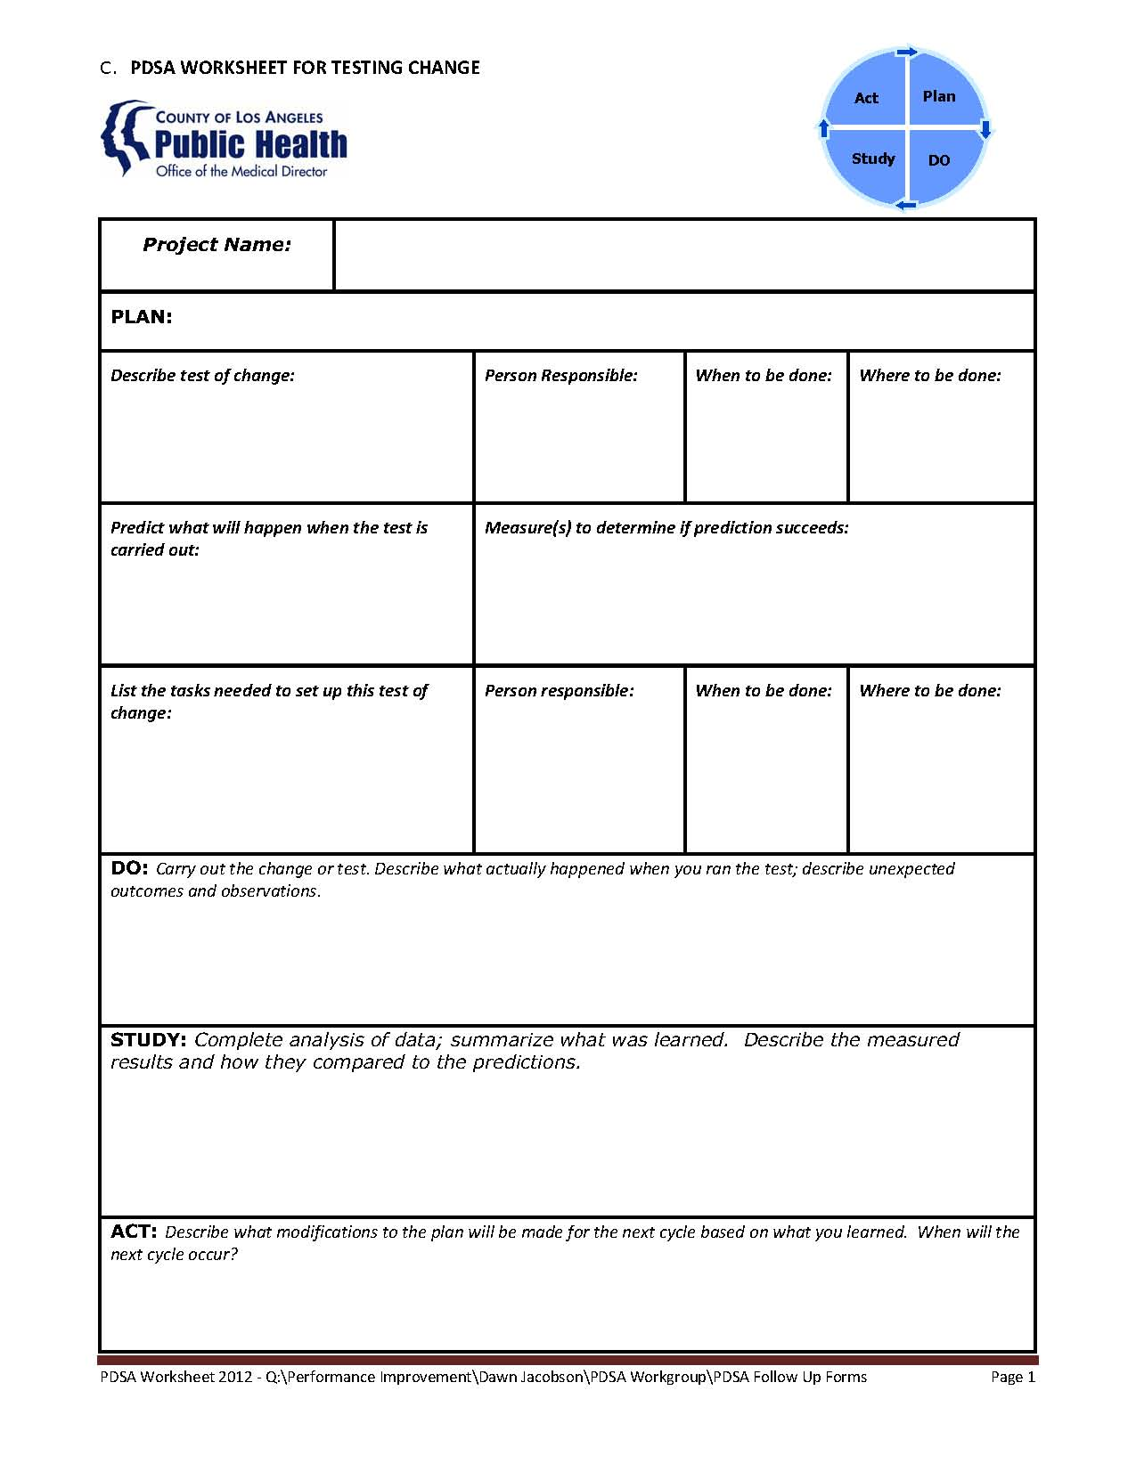

**D. QI Storyboard template**

**(Please create a storyboard like this one outlining your PI Project)**

|  |  |  |  |  |
| --- | --- | --- | --- | --- |
| <space here to Insert info about program or division> | | **Quality Improvement Story Board**  <Name of project> | | |
| Team members:  <start here> | |  |
| **PLAN**  **1. Getting started**  < AKA description of problem, how identified>  **2. Assemble the Team**  <team members>  **AIM Statement**  <start here>  **3. Examine the Current Approach**  <Might develop flow chart, complete root cause analysis>  <Sample graphic – paste in graphics where needed throughout storyboard>  **4. Identify Potential Solutions**  <how did you do this? Literature review, brainstorm> | **5. Develop an improvement theory**  <Describe solutions you think will make an improvement>  **DO**  **6. Test the theory**  <Describe your PDSA cycles> | | **STUDY**  **7. Evaluate the Results**  <start here>  <Sample graphic – paste in graphics where needed throughout storyboard>    **ACT**  **8. Standardize the Improvement**  **or Develop New Theory**  <start here>  **9. Establish future plans**  <This might include how you plan to maintain and/or spread improvements>  **10. Describe Lessons learned**  <start here> | |