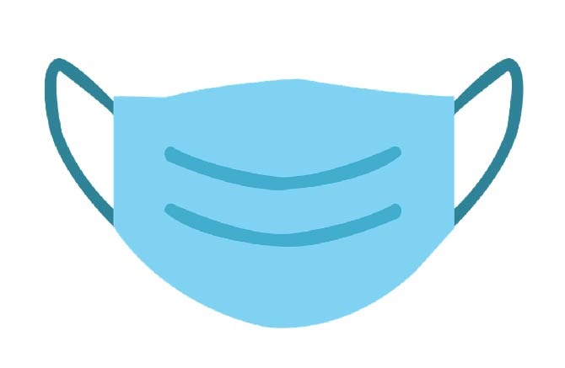

**[BUSINESS/ORGANIZATION/SITE LOGO]**

**Masks Prevent Spread**

**of COVID-19 and are**

**Required by State Regulations.**

**Masks Required**