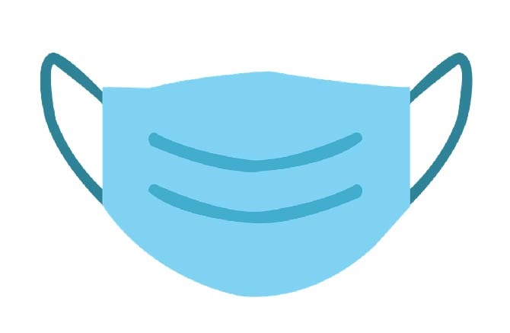

**Masks Prevent Spread**

**of COVID-19 and are**

**Required by Federal Regulations.**

**[BUSINESS/ORGANIZATION/SITE LOGO]**

**Masks Required**