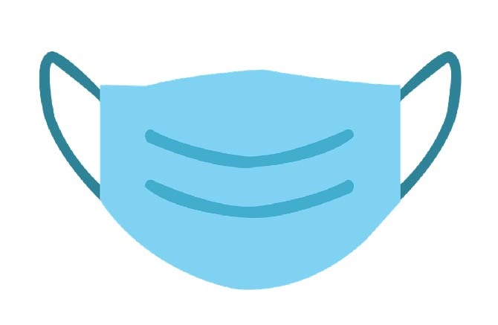

**[BUSINESS/ORGANIZATION LOGO]**

**Masks Prevent Spread**

**of COVID-19 and are REQUIRED in this area.**

**Masks Required**