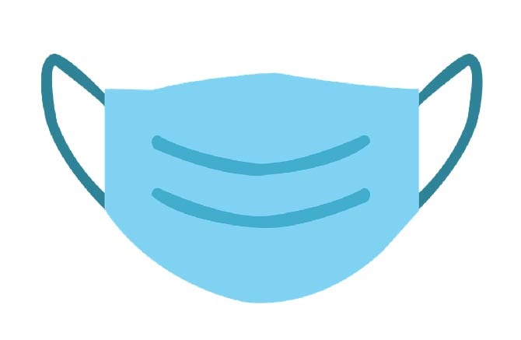

**[BUSINESS/ORGANIZATION/SITE LOGO]**

**Masks Prevent Spread**

**of COVID-19 and are Strongly Recommended by Public Health.**

**Masks Strongly**

**Recommended**